SPJ110*33/680 Mono Layer Sheet Extruder

OPERATIONAL MANUAL

Company Name: Pingyang Sinoplast Machinery Co., Ltd
Add: No. 43 Ruige Ave., Gexiang, Nanbin District, Ruian City, Zhejiang Province, China
Zip Code：325207
Web: www.sinoplast-thermoform.com
Email：info@sinoplast-thermoform.com
Tel: +86-577-63790922
Fax: +86-577-63790122
Mobile: 0086-13958816227
Content
I、Introduction ………………………………………………………………………………… 1
II、Features …………………………………………………………………………….…… 2
III、Main Technique Parameter ………………………………………………….… 3
IV、Plastic Performance Knowledge …………………….……………………… 4
V、Demonstration of Machinery
Chief Drawing ………………………………….…………………………………………… 5
5.1 Extruder ………………………………………………………………………..…… 6
5.2 Screen Changer ……………………………………………………..…………… 7
5.3 T-die ……………………………………………………………………………..…… 8
5.4 Calender ………………………………………………….………………………… 9
5.5 Winder …………………………………………………..………………………… 10
5.6 Electric Cabinet ………………………………………………………………… 11
5.7 Panel …………………………………………………………………..…………… 12
VI、Installation …………………………………………………………..……………… 13
VII、Testing & Operation ……………………………………….…………………… 14
VIII、Common Failure & Methods to Eliminate ……………….………… 15
Annex 1：Electrical Diagram …………………………………………………..…… 16
Annex 2：Spare parts ………………………………………………………..…………… 17

- Introduction
SP 110/33-660 Introduction
SP 110/33-680 plastic sheet extruder is composed of extruder，net transducer, die head，calender roller, takein machine ,electric controller etc. The operational principle of the unit is as below: According to the tristate change of thermoplastic under different temperatures and take advantage of screw’s push effect, turning physical appearance into high pellet state, and then transform into plastic liquid. After flowing from the mould, then wind in received volumes via pressure-ray cooling stereotypes. The main features of this crew as below: feed cylinder, screw and mould are made of high quality alloy structure with the nitrogen (38CrMoAlA). It has high hardness, corrosion protection, and long use span. The frame head adopts racks of guns and over. The flowing channel is suitable for the fluxion of liquid， non stagnation phenomena, the thickness of products are homogeneous, the pressure-ray roller adopts big screw shafts. It has excellent effect of adopting water cycle to cool, the temperature of feed cylinder and mould head are controlled by controller separately. The rotational speed of screw, pressure-ray machine rotational speed, rotational speed of received volumes can be adjusted respectively to ensure the speed of the whole set synchronous.
This machine is applicable to the production of PP, PE, PS, environmental protection biological degradation plastic sheet etc. It is widely used for forming of plastic sheet, packaging products, office supplies, antiseptic adhesive tape such as packaging boxes, cup, bowl, salver and so on.

- Features:
- The mould is made of high quality alloy steel, and inside is plated with hard chromium, cladding for 0.02~0.03mm, roughness for Ra0.05um, corrosion resistant.
- Screw together with feed cylinder has such features: high accuracy pitch, wear resisting, corrosion resistance, and the use of double-mixed iron-smelting structure, mixing homogeneous, high plastic performance.
- Slowdown box with hard teeth cant, the transmission straight.
- The temperature is controlled by PID, with high accuracy and quick response.
- Calendering roll adopts spiraling flume structure, and the cooling water distributed reasonably. The surface of roller cylinders is plated with hard chromium, the mirror after finishing treatment for Ra 0.05um roughness, hardness degrees for HV≥850.

- Main technique parameter
Items | Parameter | Items | Parameter
Output | 180-200kw/h | Dia. of Screw | 110mm
L/D | 33:1 | Width of T-die | 800mm
Thickness of T-die | 0.1-3mm | Length of Roller | 780mm
Dia. of Roller | 400mm | Quantity of roller | 3
Roll adjustment mode | Screw | Motor Power | 55kw
Motor power for calender | 2.2kw | Motor power for winder | 2.2kw
Barrel heating power | 15kw-35kw | T-die heating power | 15kw-20kw

- Plastic performance knowledge
4.1 PP, PE, PS belongs to thermoplastic.
Thermoplastics soften when heated and harden when cooled. They can withstand many heating and cooling cycles and are often suitable for recycling. Most thermoplastics consist of polymers, long chains of molecules that contain smaller, and repeating units called monomers. Typically, monomers are held together by covalent bonds within or between polymer chains. There is no chemical bond producing among chains of molecules, soften when heated and harden when cooled process is a physical change.
4.2 Performance of PP, PE, PS:
PS plastic
Full name: Polystyrene
Proportion: 0.94-0.96g/cubic centimeter; Forming shrinkage factor: 1.5-3.6%; Forming temperature: 140-220℃
Material performance | Electrical insulation fine (especially high-frequency insulation), colorless transparency, light transmission rate only after plexiglass, color Naishui sexual nature, good chemical stability. General intensity, but Zhicui, Yi generated stress fracture, impatience benzene. Organic solvents, such as gasoline. | It used for producing many parts, such as transparent insulated parts, decorative components, chemical apparatus etc.
Forming  performance | - Unformed material, hygroscopic capacity weak, good liquidity, it doesn’t need to drying enough before use and it’s also difficult to decompose. But the heat distensibility is strong.  - It can be formed through stuff injection molding machine.  - It should adopt high temperature of material and mould, and low injection pressure in order to decrease repulsion power inside and avoid distortion

PE Plastic
Full name：Polyethylene
Proportion：0.94-0.96 g/ cubic centimeter、Forming shrinkage factor：1.5-3.6%、Forming temperature：140-220℃
Material  performance | Electrical insulation fine (especially high-frequency insulation), bad erodibility, it can be chloridized and change the performance through radiation. The melting point, rigidity, intensity of LDPE is a little higher. It has another feature, such as bad bibulous capacity, good electric performance and good endurance of radiation. HDPE also has many features, such as good plasticity, fine tensibility, and nice osmosis. UHMWPE has good anti-wallop and durable. | LDPE is used for producing anti-erode parts and insulation components. HDPE is suitable for manufacturing film. And many damping, wearable, drive parts are made of UHMWPE
Forming  performance | - Its crystal material, hygroscopic capacity weak, good liquidity, it doesn’t need to drying enough before use. It should be formed by high-pressure injection.  - The contractive range and contractibility is great. So it is easy distortion. Accordingly, the cooling velocity should be low and the mould should equip with cooling system.  - The heating time shouldn’t be too long, in order to avoid decomposing.  - It mustn’t meet organic impregnant.

PP plastic
Full name：Polypropylene
Proportion: 0.9-0.91 g/cubic centimeter; Forming shrinkage factor: 1.0-2.5%; Forming temperature: 160-220℃
Material  performance | Low density, the intensity, rigidity and heat-resistant is better than LDPE. It can be used around 100 centigrade. Good electric performance, high frequency insulation. But it will be frangibility under low temperature, and it’s not wearable. | It can be used for producing generic mechanical parts, anti-erode parts and insulation parts.
Forming  performance | - It’s crystal material, hygroscopic capacity weak. It will decompose, if meet hot metal for long time.  - The contractive range and contractibility is great. So it is easy distortion.  - The cooling velocity is fast, and forming temperature should be controlled properly.  The thickness of plastic should be even, avoid sharpness.

4.3 Three State of thermoforming plastic
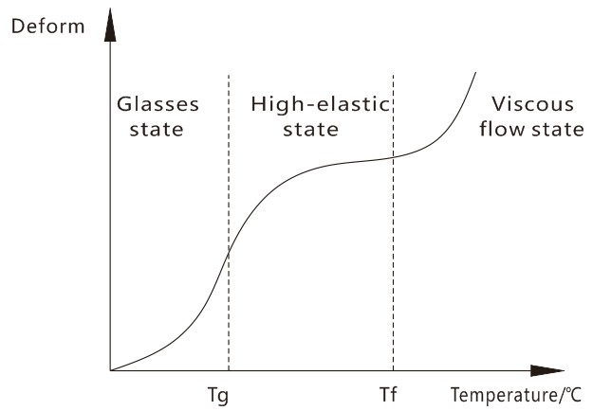
Figure 1 Deformation curve amorphous mixture
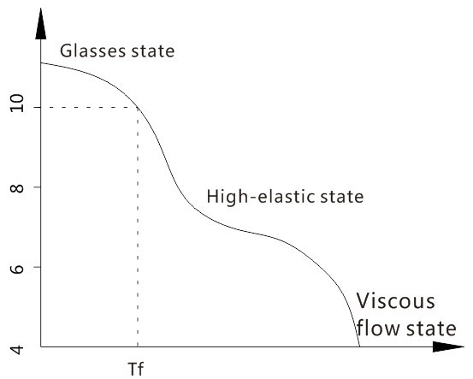
Figure 2 Amorphous polymer modulus - temperature curve
- Configuration of machine
5.1 Extruder
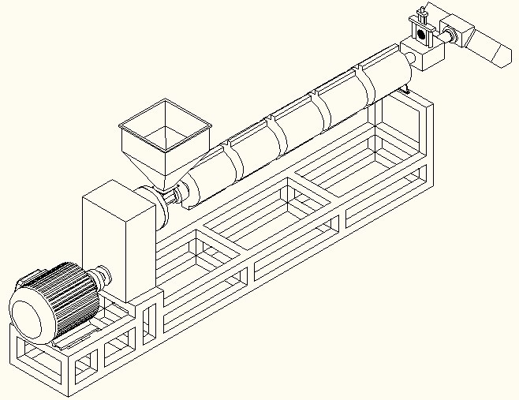
6
4
5

3

2

1
Figure 4 sheet extruder
1、foot shelf 2、reducer 3、gear box 4、hopper
5、heating circle 6、screw 7、fliter
Note：Add gear oil before running new machine
  - Screen Changer
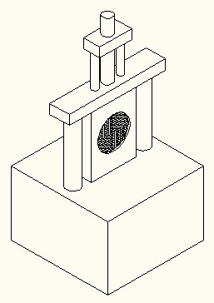

5

3

1
4
2
Figure 5 Screen Changer
1、 Net body 2、Board 3、Net Shelf 4、Pillar 5、 Cylinder
5.3 T-die
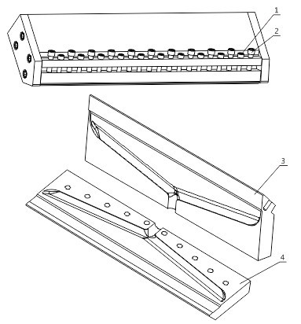
Figure 6 T-die
1、press bolt 2、stretch bolt 3、up T-die 4、down T-die
5.4 Calender
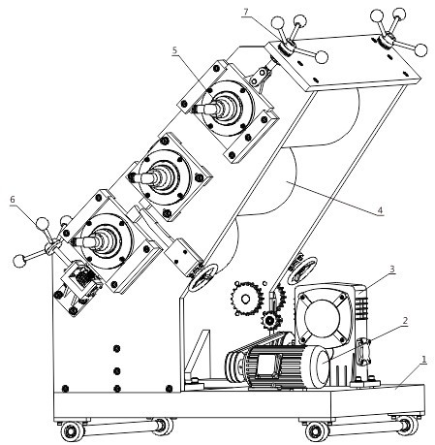
Figure 7 calender roller
1、frame 2、reducer motor 3、reducer box
4、calender 5、cooling system 6、inching wheel
7、adjust wheel
5.5 Winder
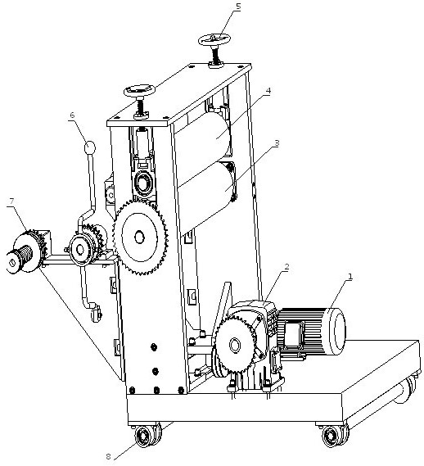
Figure 8 winder
1、motor 2、reducer 3、main traction roller 4、press traction roller
5、hand wheel 6、clutch operation pole 7、winder system 8、wheel
5.6 Electric Cabinet
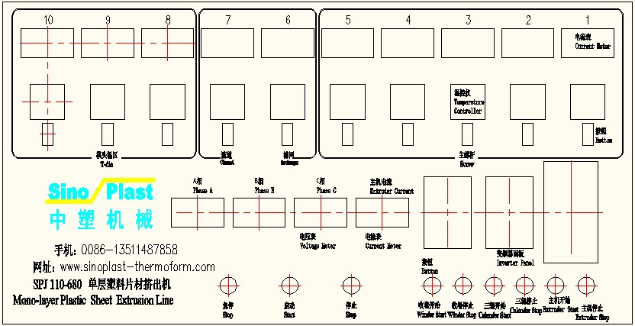
Figure 9 Electric Cabinet
Machine Structure
This machine is consist of extruder，net transducer, die head，calender roller, takein machine ,electric controller etc.
- Extruder (Figure 4)
It is composed of machine horse, timing motor, gear box, hopper, heating collar, machine barrel screw, net transducer, and die head. The whole process is as below: first change the plastic particle, which is filled in through hopper, into viscous state by heating. Then extrude plastic sheet from die head.

2、Screen Changer(Figure 5)
This part includes net frame, lacunaris board, front-dictyosome, back-dictyosome, column, up/down gear box and motor. The main function of it is to change the movement of material from whirligig into beeline movement, avoiding leting impurity and un-plasticized particles into die head. It also can increase the pressure on the material to make the sheet more close-grained.
3、T-die（Figure 6）：
It is designed as clothes rack degression type, and composed of up/down mould, inching system and heating frame. The function is to produce essential forming pressure, in order to make particles mix even and plasticize well. Through the die head, extrude the forming sheet embryo. Then come the next procedure: calender roller.
4、Calender（Figure 7）：
It is mainly composed of frame, calender roll shaft, gear box, timing motor, cooling system etc. The main function is pressing on the embryo sheet to form needed thickness and making the surface of sheet smooth and burliness.
5、Winder（Figure 8）：
This part is mainly constituted of frame, traction roll shaft, timing motor, cutting set, wind-in equipment etc. Its function is cooling the sheet, which is processed from calender roller, to make the sheet solidify. The next process is cut the sheet into demanded specification by cutting set. And the function of winding machine Is to wind in sheet.
6、Electric Cabinet（Figure 9）：
Figure 10 Panel
Operation：
1、Voltmeter: Three voltmeters indicate voltage of tri-phase power.
2、Power switch: Control the whole panel power. Once it turns off, the whole panel switches disabled. All the meters undisplay. Before turn on machine, you should turn on the power switch first.
3、Ammeter: Indicate the main machine’ s current.
4、Urgent stop: If you press down this button, all switches and meters disabled except the voltmeter have reading and the power indicator lighting. After eliminating the fault, press deasil down this button, then all the function of the panel becomes effective.
5、Winder start: The wind-in motor start after pressing down this button, which drives the main traction roller revolve to wind the sheet.
6、Winder stop: Press down this button, the winder motor stop working and the main traction roller also stop. So the winder stops winding in sheet. This button is usually used after all the work is finished.
7、Filtering net up: When there are some impurity on the filtrate net, press down this button and the motor revolve to drive the lacunaris board ascending .Then you can replace the filtering net. But before using this button, you should ensure that the main machine should be in the unworking state.
8、Filtering net down: After replace a new filtering net, press down this button to make the lacunaris board come back. Then you can turn on the main machine to work.
9、Main machine actiyator: It can adjust the velocity of main machine’s motor. When the temperature of the main machine rise to setted temperature and there isn’t any impurity on the filtering net, then use this actiyator after adjusting the thickness of the die head. The velocity of extruding sheet is connected with the revolve speed of the motor.
10、Main machine transducer: Used for starting up the main machine.
11、Calender actiyator: Used for adjusting the velocity of the motor of tri-roller. Levorotation becomes fast, and opposite becomes slow.
12、Calender transducer: Used for starting up the motor of the tri-roller.
13、Winder actiyator: Used for adjusting the revolving velocity of the winder motor. Levorotation becomes fast, and opposite becomes slow.
14、Winder transducer: Used for starting up the winder motor.
15、Main machine start: When the temperature of main machine reaches the setted temperature, turn on this button to start up the main machine for extruding the sheet.
16、Main machine stop: The main machine stop work after pressing down this button.
17、Tri-roller start: Press down this button, the tri-roller starts revolving to make the embryo sheet into plastic sheet.
18、Tri-roller stop: Press down this button, the tri-roller stops revolving.
Note：Details of temperature controller operation please see 5.7.1

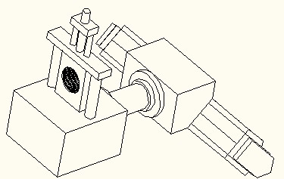

Zone E

Zone D

Zone B
Zone A
Zone C

Figure 11 T-die heater
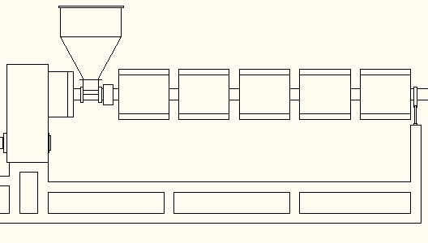

Zone D
Zone C
Zone B
Zone A
Zone E

Figure 12 Screw heater
5.7.1 Operation of Temperature Controller
Figure 13 Temperature Controller
In the PID parameter set mode, each time press SET button, will display the below parameter sequentially:
Sign | Name | Set | Description | Initial value DH3 | Initial value DH2
ITV | Over rush choke back | 0-200℃ | Use for stop procreant up over rush or down over rush because of integral effect | 010 | 010
ALV | Alarm parameter | 0-100℃ | Set upper limited and lower limit alarm warp value | 010 | 010
INV | Temperature zone set | 10-100 | Amend data can set temperature tolerance, from 0-100℃~0-999℃. Max. tolerance: INV*10℃ | 40 | 040
PV | Proportional band | 1-100%*0.1% | Set the heating proportional band PV = 0 for the bit-type heating control | 050 | 50
IV | Integral Time | 1-200*10S | Eliminate static error, IV = 0 for PD heating control | 062 | 40
DV | Derivative time | 0-200S | 1.For fluctuations advance control. 2. DV = 0 for PI heating control. 3. PV = 0, this parameter is lower return difference. | 080 | 20
OSV | Output base value | 0-200 | This value is used to adjust the current output is superimposed on the minimum value for the output 0-200 | 0 | Non
OTV | Output smoothly filtering | 0, 1 | 0 is for smoothly, 1 is feedback quickly（DH2without such function） | 1 | Non
PIV | Output type | 0, 1 | Intermittent output is 0, the continuous output is 1 | Non | 0
TV | Heating cycle | 0-100S | Set the controller output cycle time (heating side) | 003 | 020
BTV | Temperature correction parameter | 0-200℃ | To correct the temperature error, the default value is 100 (corresponding to the ambient temperature), each unit is 1 degree | 100 | 100
ATV | Autotune | 1, 2, 3 | Use to PID parameters automatically adapt to the user's automatic calculation function | 000 | 000
LKV | Parameter Lock | 0, 1 | All internal parameter lock when 000, , the inner parameter allows to modify when 001 | 000 | 000
Set SV Parameter
- Press the SET button, the up display shows the SV, the lower bit character flashes, then the instrument can enter the set state.
- Press (<)、 (▽)、 (△)、or press (▽)、and (△) can change the set value or continuum change set value.
- After finished the setting, press SET button, controller resume PV/SV display state, save the parameter, and instrument enter working state.

Set PID parameter
1、Press “SET” key around 5 seconds，enter to PID parameter setting state, continuum press SET key till disappear data LKV, change LKV data to 1, then can be amended needed setting parameter.
2、Press (<)、 (▽) and (△) to set the parameter data. Or press (▽) and (△) to change the setting parameter data.
3、After finished setting, press SET key around 5 seconds, controller resume PV/SV display state, save the parameter.

- Installation
6.1 main parts installation
1. Power wastage of main machine:
Including: Extruder: 37~45KW Tri-roller calender: 4KW
Winding machine: 2.2KW Heating power: 32~38KW
2. Dimensions (L*W): 10.5*2.2*18(M³)
3. The requested area to produce: 45 square meter
4. The needed height of the factory: 2.5M
5. Installed groundwork: concrete even ground
6. Installing requirement
A：Put the whole set on the ground orderly, according to sketch map (map 3)
B：Take the extruding machine cylinder’s central line as the unit’s installed core axle line. The other equipment are installed according to the core axle line
C: adjust the axle line of extruding cylinder, calender roller, winding machine’s roller, tractive roller and the transverse lines of die head to the level state.
D: the installation distance between calender roller and die head should between 50~100mm, and drive the calender forward or backwards through impulse the wheel.

6.2 installation of the electric equipment
1. This unit adopts tri-phase and four-wire power supply, alternating current: 380V/50Hz.
The whole power of this unit is about 70KW. The power wire should be connected through
a hole in the bottom of the electrical case, then link to A,B,C,N connection ports. Especially, there should be wire connecting well into the earth and link with the earth wire of the electric case.
- Connect the down-leads of Extruder and motor with the wires in the electric case according to the connection numbers. Then link the plugs of tri-calender and taken machine to jacks in the left side of the electric case. And so does the plug of the controlling wire.

- Demonstration of Machinery
Demonstration Processes:
  - Clear up the workshop before testing the machinery.
  - Add lubricant to very gear cases, gearing parts and axletree.
  - Close the air switch QF２,then the indicated light of “power off” in the controlling board will be turned on. Press down the “power on” switch to collect with the power, the “power off” indicated light will turn off and the “power on” indicated light turns on when the power successfully connects.
  - Turn on the switches of Area “D” in the board, and adjust the temperature of temperature controllers to 100 degree. In the end, turn on the other switches.
  - Ensure the temperature of the whole temperature controllers reaches as below: screw controlling area A is between 218~222 degrees; Area B is between 208~212 degrees; area C is between 190~200 degrees; area D is between 175~180 degrees. And the temperature of die head should reach the melting temperature of plastic, the temperature of area “D” is about 10 degree higher than area “A”、 “B”、and “C”.
  - Startup the main machine
  - Startup tri-roller calender
  - Startup the winder machine

Note:
- Do not startup the main machine and strainer before reaching the thermoforming temperature.
- Do not let the cooling material into the tri-roller.
- Close the main machine and tri-roller before raising the strainer in order to avoid demolishing these two parts.
- Abide to the test procedure of machine.
- Common Failure & Methods to Eliminate
Malfunctions | Potential Reasons | Solution
It’s noisy in the Extruder | 1. There may be some eye winkers in the material cylinder.  2. Axletree of reducer casing is destroyed.  3. The hopper is blocked or there is little raw material in the cylinder | 1. Clear the eye winker in the material cylinder.  2. Replace a new axletree.  3. Stop work, add the raw material into the cylinder.
The transmission chain is broken off | 1. The chain is installed too loose or tight.  2. The chain is worn and toted badly | 1. Adjust the degree of tightness of the chain.  2. Exchange a new chain.
The plastic sheet is parted | 1. The temperature of the material cylinder or mold die is a little lower.  2. The dehiscence of the mold die isn’t big enough.  3. The winder velocity is too quickly. | - Enhance the thermoforming temperature.  - Increase the dehiscence of the mold die.  3. Adjust the speed of the winder or calender
The thickness of the extrusion sheet isn’t well-proportioned. | - The temperature of the mold die isn’t well-proportioned.  - The dehiscence of the mold die isn’t evenly  - The speed of winder isn’t stably.  The space between the rollers isn’t evenly. | - Examine or repair the heating equipment and adjust the temperature of the mold die.  - Examine or Repair the inching switch to adjust the dehiscence of the mold die.  - Examine or Repair the winder.  Adjust the place between of rollers
There is air bubble in the extrusion sheet | The raw material may be moist or there may be volatile material in the raw material | Dry the raw material
There are lengthways lines in the extrusion sheet | 1. The mold die is destroyed.  2. The mold die is blocked by impurity.  3. The surface of the rollers is destroyed. | 1. Polish the surface of the mold die.  2. Clear the mold die.  3. Exchange a new roller.
There are atramentous or abnormal colored speckles appearing in the extrusion sheet | 1. The raw material is decomposed because of the high thermoforming temperature.  2. There may be dead angle in the mold die, and the blocked material is decomposed.  3. There may be impurity sticks to the surface of the roller. | 1. Adjust the temperature of the mold die.  2. Amend the mold die and eliminate the dead angle.  3. Clear the mold die and eliminate the block.  4. Clear the surface of the roller and examine the prescription of the material.
There are a flock of transverse protuberance in the extrusion sheet | - The temperature of the mold die is high in the mid and lower in both sides  - The rotate speed of the screw is too fast.  The dehiscence of the mold die isn’t evenly | - Adjust the temperature of the mold die.  - Reduce the rotate speed of the screw and adjust the dehiscence of the mold die.
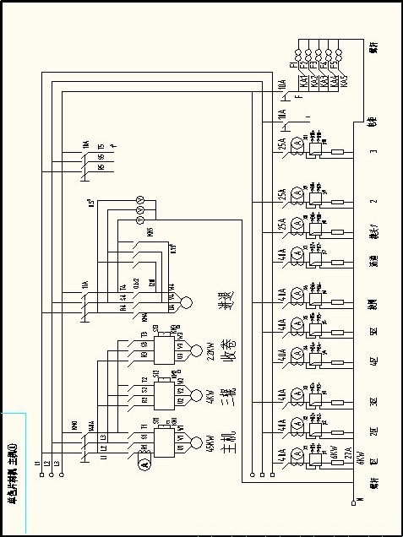Annex 1： Electrical Diagram
